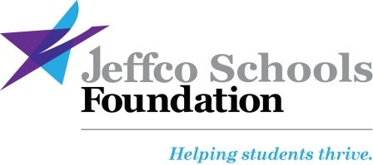

September 2017

Dear Jeffco Public Schools Principal,

Jeffco Schools Foundation will again partner with Red Rocks Community College and community supporters to present the annual Hero Awards. The Foundation values recognition, and understands its importance towards achieving our mission-- to connect the community Jeffco classrooms, and bring resources and partnerships to bridge gaps facing the District, schools, teachers, and students.
We aim to recognize four high school seniors who demonstrate exemplary character, commitment to completing their academic career and selflessness towards others despite overcoming personal adversity. The Award also recognizes teachers who model extraordinary commitment to their students, their school communities and their profession, going above and beyond, the already taxing requirements of being a teacher.
Four Jeffco high school seniors will receive:
- A reserved table for their guests
- A full two-year tuition scholarship to Red Rocks Community College
- A $1,000 Academic Award
- A goodie bag with gift certificates and awards from merchants around Jefferson County
- A copy of a special video produced in their honor
Three Jeffco teachers will receive:
- A reserved table for their guests
- A three-credit hour professional development certificate to Red Rocks Community College to study any topic
- A $500 classroom/professional development grant
- A goodie bag with gift certificates and awards from merchants around Jefferson County
- A copy of a special video produced in their honor

Attached are nomination guidelines. Please send your nomination to Denise Delgado at Jeffco Schools Foundation via email dldelgad@jeffco.k2.co.us no later than 5 p.m. on Monday, October 9th, 2016.
Thank you for helping us shine a bright light on those who often go unnoticed. Please call me if you have any questions: 303-982-2261.

Sincerely,
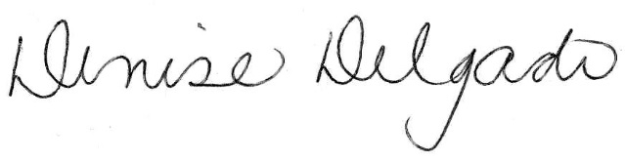

Executive Director

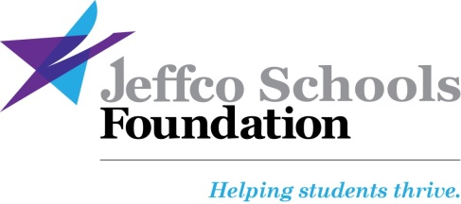

Guidelines for Nomination Jeffco Schools Foundation’s Hero Awards

Deadline: Return completed form by Monday October 9, 2017 to denise.delgado@jeffco.k12.co.us
Jeffco Schools Foundation is pleased to present the Hero Awards, an annual recognition event honoring Jeffco Public Schools students and teachers of extraordinary character, leadership and strength.
The Hero Awards will be held from 6:30 to 8:30 p.m., November 13th at the Denver West Marriot in Golden
The awards will honor four graduating seniors and three teachers—one from elementary, one from middle and one from high school.
Honorees will be chosen by a volunteer selection committee comprised of community leaders/educators, representatives of the event sponsors and Jeffco Schools Foundation Board members.

Student Hero award criteria:  - Student has overcome extraordinary personal circumstances in order to succeed  - Current senior poised to graduate in the 2017/2018 school year  - A senior who might not otherwise have the opportunity to attend college due to financial circumstance.  - An attitude of selflessness towards and their school community despite personal adversity or challenge  - Exceptional character and resiliency and ability to inspire others  - Student must attend event to receive award | Teacher Hero award criteria:  - Exemplary dedication to their students and school  - Innovation in the classroom; poised to leave an educational impact/legacy at the school due to implementation of unique classroom contributions  - Commitment to profession of teaching  - An attitude of service and generosity to others and their school community beyond teaching in the classroom; ability to inspire others  - Teacher must attend the event to receive award
To nominate a student and/or teacher:
You send use this Google document link to submit your nomination https://goo.gl/forms/e6D9ea7Ko9T2FsAS2.The document is set up in paragraph form for the Principal to submit at least a one, up to two page, narrative. There are no formatting requirements. Other staff can use this link to write your nomination, however, forms need to be sent in by the Principal with administrator approval.
To assist the selection committee in choosing the final honoree, please use specific examples to illustrate the student’s or teacher’s qualifications for the award, in particular detailing personal circumstance and temperament, using story telling as a tool for the strongest nomination.
This award is intended to recognize the “diamond in the rough” or the “silent leader”; the person who is not motivated by accolade, yet is deserving of it and the selection committee is hopeful your narrative will share these qualities. This is not an academic or activity based award and narratives should be a list or resume of the nominee’s activity.
Please be aware that the nomination may be posted on Jeffco Schools Foundation’s website and distributed to media sources (only as approved by the honoree) and all nominations are kept confidential as personal and private stories are typically shared.
- Current elementary, middle or high school teachers and current high school seniors in a Jeffco neighborhood, charter or option school or special program are eligible for nomination.
- Each high school may nominate one graduating senior AND one teacher.
- Elementary and Middle Schools can nominate one teacher.
- Nominations for teachers and students should be separate documents.
- Pre-K and K teachers are eligible to be nominated under the elementary school category; high schools which include grades 7-12 may submit two teacher nominations based on grade level (middle and high school).
- Nominating principals must be available to attend the Hero Awards event with their honoree.
- Other staff can help in the selection process and write the nomination, however only one nomination will be accepted and it MUST be supported by the school principal.
- Schools will be expected to assist in scheduling a video of honorees in partnership with the District Communications office.
- All nominated students and teachers will be notified of decisions by Friday, October 13th, 2017.
Submit Nominations via Google Form https://goo.gl/forms/e6D9ea7Ko9T2FsAS2 which will only go to the Executive Director of the Foundation by Monday, October 9th, 2017
Questions? Contact Denise Delgado at 303.982.2261 or denise.delgado@jeffco.k12.co.us

809 Quail Street, Building 1, Lakewood, CO 80215, 303-982-2210
www.jeffcoschools foundation.org

